**MongoDB Notes:**

1. **Database Internals:** 
   1. The database system has two parts: The API DATA Format and The Storage Engine.
   2. Earlier it used to be, tables only like SQL. The API and Data Format for SQL is the constraint which forces the bytes to be arranged in a tabular kind of form. But it can be moulded to have documentation etc.
   3. Storage and indices work to store and retrieve data. Type of indices help to pinpoint the retrieval part, where and what to 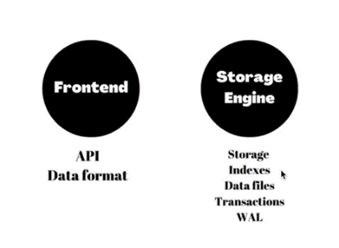read. And the Storage decompresses it and gives it back.
   4. Storage engine is responsible for transactional overview.
   5. We do not have byte addressability on ROMs, so you write in terms of page sizes, and not one single byte, so the moment you touch a page, it is termed as dirty, because it will collect all the changes you made to it, and flush it once in the server memory, to save transactional costs.
   6. WAL: As we write to the data pages, as journals, which takes note of the changes we make, and make checkpoints. We apply the WAL, and redo/undo as we want it to be.
   7. **SQL vs NOSQL** main differences are based on Front end chunk.
2. **MongoDB v<4.2**
   1. Offset tells us which part to read in our file of 1 gb.
   2. Locking: Two clients accessing the same file. No two transactions can change one document concurrently, in the very initial versions.
3. **Wired Tiger 4.2.5**
   1. 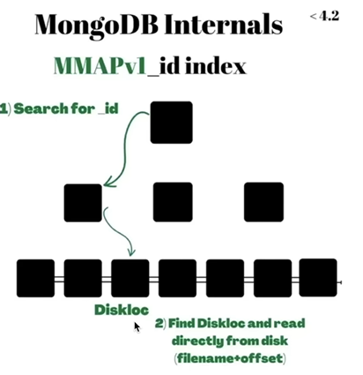This version allowed to update two different documents, on the same collections, concurrently. The same row on the same table. Column level locking – update different column in the same row. But not feasible due to memory acquirement of lock hashing.
4. **Clustered Collections >5.3**
   1. This is the main model. Id index is what we start to look for? I don’t understand much. Almost identical to MYSQL.
   2. The secondary index points to the id now. The id field is 12 bytes by default, which is a lot. Universally identical. It is a user controlled field.

[Beautiful video](https://youtu.be/DZBGEVgL2eE) <- watch this because the corresponding part in course is way too deprecated.

[MONGOOSE BEST VIDEO QUICK QUICK](https://youtu.be/DZBGEVgL2eE) <- from WDS.

1. **Error: TypeError: user is not a constructor. Basically, was not able to export the model from the schema file.**

[**Solution**](https://forum.freecodecamp.org/t/cant-export-require-a-module-mongoose-model-typeerror-user-is-not-a-constructor/452317/5)**: To export only schema and not the model from the other file.**

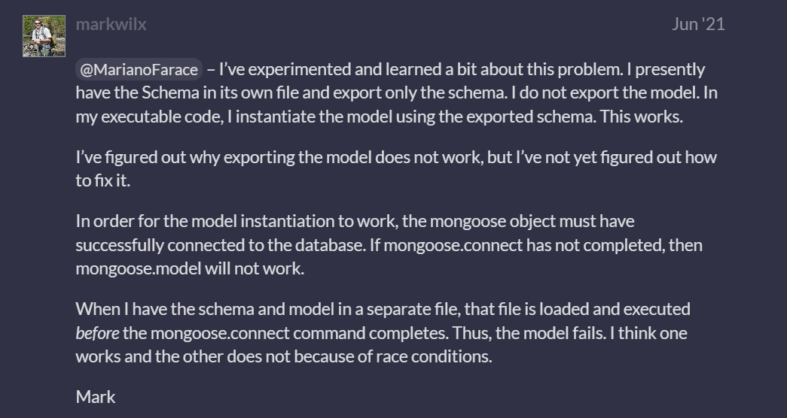

1. Error: If I run mongod in a terminal in E drive, it requires a different path for data/db in E drive. If I do not create that folder in E drive, it does not work.

I had to create a similar path in C drive in E drive , that was in installation instructions so it makes sense, and the same is written in config file. But when I run in E drive, why does it look for that in E drive, and not in the path as mentioned in C drive.

1. [I thought db was a placeholder for the name of the db. Thanks, it works now.](https://stackoverflow.com/questions/69565158/mongo-shell-throws-referenceerror-db-is-not-defined-even-when-i-am-connected-a)
2. **Error: Was not able to save data, schema was not exported rightly.   
   Solution:** module.exports works to export, but module.export does not, even though I noticed export in several docs. Idky. This also solved error. But I can not access help menu like typing “ user.” Will not pop up the list of available functions for some reason.
3. Async functions will return a promise, and never the value accessed by the function creating the promise.  
   Solution links – [Promise pending](https://stackoverflow.com/questions/38884522/why-is-my-asynchronous-function-returning-promise-pending-instead-of-a-val) , [Beautiful github repo discussion](https://github.com/Keyang/node-csvtojson/issues/278#:~:text=think%20I%20might%20have%20been%20unclear%20in%20my%20earlier%20comment)
4. [Model.find({}) documentation](https://mongoosejs.com/docs/api/model.html#model_Model-find) <- Read this to understand what the function returns, and if it needs to be await-ed.
5. Error: Saving data not converting to schema  
   Solution:here
6. Error: forEach function was not working in EJS?   
   [Solution: HTML Collection does not have forEach methods. Convert to array.](https://stackoverflow.com/questions/35969974/foreach-is-not-a-function-error-with-javascript-array)
7. [I don’t understand this error](https://stackoverflow.com/questions/61800062/error-querytxt-etimeout-when-connecting-to-mongodb-atlas-using-mongoose/63912290?answertab=scoredesc#tab-top) <- switch on off wifi or system? What kinda solution is this. Network resetting?
8. Sending multiple values through one input: [Use hidden input.](https://stackoverflow.com/questions/37273220/how-can-i-send-two-values-with-one-button) (idk if it is a good practise or not. But works for now.
9. [Use of exec()](https://stackoverflow.com/questions/31549857/mongoose-what-does-the-exec-function-do)